FY 2022
OPERATING BUDGET
DECISION PACKAGE
Requesting Dept: MEA |  |  |  |  |  |  |  |  |  | Division: Marina Enterprise
Contact Person: Brian W. Taylor, Harbormaster |  |  |  |  |  |  |  |  |  | Dept. Priority: 1 of 5
- Decision Package Title: Marina Enterprise Operations Line Items Increase

- Strategic Plan Priority: Public Health and Safety, Infrastructure

- Classification | Non-Discretionary (Change in law, utility incr., etc.) |  |  |  |  |  |  |  |  |  |  | Discretionary  X
- Decision Package Request:

Maintain current level of service
x

 |  | Enhanced/Expanded level of service
 |  | Operating Capital
 |  |  |  |  |  | New Item
 |  |  |  |  |  | Replacement
(Describe item, new or replacement, in Detailed Description paragraph below)

- Detailed Description of Request:

Requesting to increase operational expenses for the Marina Enterprise Program.

- If request is involves a position - Attach Employment Requisition form and proposed position description
- If operating capital item - Attach Operating Capital Item Request Listing Form

- Rational/Justification for Request:

An increase in operating expenses by $5,500 is requested to maintain the level of service required to run our municipal Town of Barnstable Marinas. The line items requesting to increase are Marine Related Services, Gasoline, Uniforms, Boats/Equipment and Ice/Water Expenses. In FY2021, due to budget reductions funding was cut. The Marina Operations Enterprise Account was not negatively affected by COVID-19 and the program actually saw an increase in transient dockage usage therefore, seeing an increase in revenue generated.

- How Efficiency and Effective will this Request be providing this Service? (Explain):

In order to continue to maintain the expected level of services at our marinas, we need to increase our budget.

- Impact on Service if Not Funded (Explain):

Without adequate funding, our facilities and operation may be negatively impacted.

- Breakdown of Total Costs By Line Item:

Expense Line Item |  |  | Account Number
Description |  |  | Org Code |  |  |  |  | Object Code |  |  |  |  | Amount
Marine Related Services |  |  | 668023 |  |  |  |  | 621050 |  |  |  |  | $3000
Gasoline |  |  | 668023 |  |  |  |  | 636010 |  |  |  |  | $750
Uniforms |  |  | 668023 |  |  |  |  | 641030 |  |  |  |  | $400
Boats/Equipment |  |  | 668023 |  |  |  |  | 674020 |  |  |  |  | $500
Ice/Water Expense |  |  | 668023 |  |  |  |  | 641160 |  |  |  |  | $400
 |  |  |  |  |  |  |  |  |  |  |  |  | $
 |  |  |  |  |  |  |  |  |  |  |  |  | $
 |  |  |  |  |  |  |  |  |  |  |  |  | $
 |  |  |  |  |  |  |  |  |  |  |  |  | $
 |  |  |  |  |  |  |  |  |  |  |  |  | $
 |  |  |  |  |  |  |  |  |  |  |  |  | $
 |  |  |  |  |  |  | Total Expenses |  |  |  |  |  | $5050
- Revenue Offsets: |  |  |  | Yes  x |  |  |  |  | No
Explanation if Yes Above Explain By Describing Funding Sources: Funding offset will be user fees generated from Marina Enterprise Program.

Funding Offsets (Fees, Grants, Internal, Budget Line Transfer)
Proposed Funding Source |  |  |  | What is the Price or Lump Sum? |  |  |  |  |  |  | Amount
Enterprise Account User Fees |  |  |  | $5050 |  |  |  |  |  |  | $5050
 |  |  |  |  |  |  |  |  |  |  | $
 |  |  |  |  |  |  |  |  |  |  | $
 |  |  |  |  |  |  |  |  |  |  | $
 |  |  |  |  |  |  |  |  |  |  | $
 |  |  |  |  |  |  |  |  |  |  | $
 |  |  |  |  |  |  | Total Offset |  |  |  | $5050
 |  |  |  |  | Net Bal. (Expenses – Revenues) |  |  |  |  |  | $0
- Further Explanation if Needed:

ATTACHMENT: Please provide any support (including photos) for cost for materials or comparable personnel wages.

FY 2022
OPERATING BUDGET
DECISION PACKAGE
Requesting Dept: MEA |  |  |  |  |  |  |  |  |  | Division: Marina Enterprise
Contact Person: Brian Taylor, Harbormaster |  |  |  |  |  |  |  |  |  | Dept. Priority: 2 of 5
- Decision Package Title: Dock Replacement and Maintenance

- Strategic Plan Priority: Public Health and Safety, Infrastructure

- Classification | Non-Discretionary (Change in law, utility incr., etc.) |  |  |  |  |  |  |  |  |  |  | Discretionary  x
- Decision Package Request:

Maintain current level of service
x

 |  | Enhanced/Expanded level of service
Operating Capital
x
 |  |  |  |  |  | New Item
Replacement
x

(Describe item, new or replacement, in Detailed Description paragraph below)

- Detailed Description of Request:

Continuation of capital funds for the replacement/maintenance of marina floats, hardware, and gangways.

- If request is involves a position - Attach Employment Requisition form and proposed position description
- If operating capital item - Attach Operating Capital Item Request Listing Form

- Rational/Justification for Request:

Due to outdoor elements and use, the docks/floats and gangways have become safety hazards for the public use. Ongoing replacement and maintenance is mandatory for use of the marina facilities in a safe manner.

- How Efficiency and Effective will this Request be providing this Service? (Explain):

Public/user safety and usable dock/floats.

- Impact on Service if Not Funded (Explain):

Public safety could be jeopardized, loss of property, damage to Town and private property, safety of users.

- Breakdown of Total Costs By Line Item:

Expense Line Item |  |  | Account Number
Description |  |  | Org Code |  |  |  |  | Object Code |  |  |  |  | Amount
Dock Replacement |  |  | 668023 |  |  |  |  | 702000 |  |  |  |  | $25,000
 |  |  |  |  |  |  |  |  |  |  |  |  | $
 |  |  |  |  |  |  |  |  |  |  |  |  | $
 |  |  |  |  |  |  |  |  |  |  |  |  | $
 |  |  |  |  |  |  |  |  |  |  |  |  | $
 |  |  |  |  |  |  |  |  |  |  |  |  | $
 |  |  |  |  |  |  |  |  |  |  |  |  | $
 |  |  |  |  |  |  |  |  |  |  |  |  | $
 |  |  |  |  |  |  |  |  |  |  |  |  | $
 |  |  |  |  |  |  |  |  |  |  |  |  | $
 |  |  |  |  |  |  |  |  |  |  |  |  | $
 |  |  |  |  |  |  | Total Expenses |  |  |  |  |  | $25,000
- Revenue Offsets: |  |  |  | Yes  x |  |  |  |  | No
Explanation if Yes Above Explain By Describing Funding Sources: Funding offset will be user fees generated from Marina Enterprise Program.

Funding Offsets (Fees, Grants, Internal, Budget Line Transfer)
Proposed Funding Source |  |  |  | What is the Price or Lump Sum? |  |  |  |  |  |  | Amount
Marina Enterprise Fees |  |  |  | $25,000 |  |  |  |  |  |  | $25,000
 |  |  |  |  |  |  |  |  |  |  | $
 |  |  |  |  |  |  |  |  |  |  | $
 |  |  |  |  |  |  |  |  |  |  | $
 |  |  |  |  |  |  |  |  |  |  | $
 |  |  |  |  |  |  |  |  |  |  | $
 |  |  |  |  |  |  | Total Offset |  |  |  | $25,000
 |  |  |  |  | Net Bal. (Expenses – Revenues) |  |  |  |  |  | $0
- Further Explanation if Needed:

ATTACHMENT: Please provide any support (including photos) for cost for materials or comparable personnel wages.

FY 2022
OPERATING BUDGET
DECISION PACKAGE
Requesting Dept: MEA |  |  |  |  |  |  |  |  |  | Division: Marina Enterprise
Contact Person: Brian W. Taylor, Harbormaster |  |  |  |  |  |  |  |  |  | Dept. Priority: 3 of 5
- Decision Package Title: Bismore Park Marina Timber and Dock Repairs

- Strategic Plan Priority: Infrastructure, Public Health and Safety

- Classification | Non-Discretionary (Change in law, utility incr., etc.) |  |  |  |  |  |  |  |  |  |  | Discretionary  X
- Decision Package Request:

Maintain current level of service
x

 |  | Enhanced/Expanded level of service
Operating Capital
X
 |  |  |  |  |  | New Item
Replacement
X

(Describe item, new or replacement, in Detailed Description paragraph below)

- Detailed Description of Request:

On September 25th, 2018 Foth-CLE performed nondestructive visual inspections on the all of the existing timber structures located at Bismore Park Marina in Barnstable, MA. This inspection was part of a larger condition assessment that was conducted at Bismore Park and Gateway Marina for the Town of Barnstable. The final condition assessment report provided a full list of all observed structural deficiencies and described the overall condition of all existing waterfront infrastructure. This request is intended to address the prioritized repairs to maintain the structural capacity of the timber pier structures prior to bulkhead replacement.

- If request involves a position - Attach Employment Requisition form and proposed position description.
- If operating capital item - Attach Operating Capital Item Request Listing Form.

- Rational/Justification for Request:

Continued deterioration of the timber pier structures, possible damage to vessels, and compromised safety to users.

- How Efficiency and Effective will this Request be providing this Service? (Explain):

Public/user safety and usable dock/floats/bulkhead.

- Impact on Service if Not Funded (Explain):

Public safety could be in jeopardized, loss of property, damage to Town and private property, safety of users.

- Breakdown of Total Costs By Line Item:

Expense Line Item |  |  | Account Number
Description |  |  | Org Code |  |  |  |  | Object Code |  |  |  |  | Amount
Bismore Park Repairs |  |  | New |  |  |  |  |  |  |  |  |  | $30,000
 |  |  |  |  |  |  |  |  |  |  |  |  | $
 |  |  |  |  |  |  |  |  |  |  |  |  | $
 |  |  |  |  |  |  |  |  |  |  |  |  | $
 |  |  |  |  |  |  |  |  |  |  |  |  | $
 |  |  |  |  |  |  |  |  |  |  |  |  | $
 |  |  |  |  |  |  |  |  |  |  |  |  | $
 |  |  |  |  |  |  |  |  |  |  |  |  | $
 |  |  |  |  |  |  |  |  |  |  |  |  | $
 |  |  |  |  |  |  |  |  |  |  |  |  | $
 |  |  |  |  |  |  |  |  |  |  |  |  | $
 |  |  |  |  |  |  | Total Expenses |  |  |  |  |  | $30,000
- Revenue Offsets: |  |  |  | Yes  x |  |  |  |  | No
Explanation if Yes Above Explain By Describing Funding Sources: Funding offset will be Marina Operations Program Surplus funds.

Funding Offsets (Fees, Grants, Internal, Budget Line Transfer)
Proposed Funding Source |  |  |  | What is the Price or Lump Sum? |  |  |  |  |  |  | Amount
Marina Operation Program |  |  |  | Surplus |  |  |  |  |  |  | $30,000
 |  |  |  |  |  |  |  |  |  |  | $
 |  |  |  |  |  |  |  |  |  |  | $
 |  |  |  |  |  |  |  |  |  |  | $
 |  |  |  |  |  |  |  |  |  |  | $
 |  |  |  |  |  |  |  |  |  |  | $
 |  |  |  |  |  |  | Total Offset |  |  |  | $30,000
 |  |  |  |  | Net Bal. (Expenses – Revenues) |  |  |  |  |  | $0
- Further Explanation if Needed: Surplus funds available currently exceed the recommended one (1) year buffer in operating expenses.

ATTACHMENT: Please provide any support (including photos) for cost for materials or comparable personnel wages.
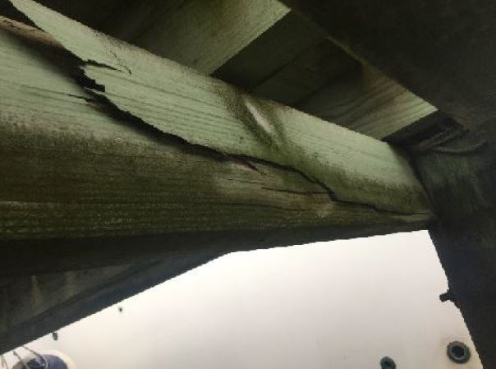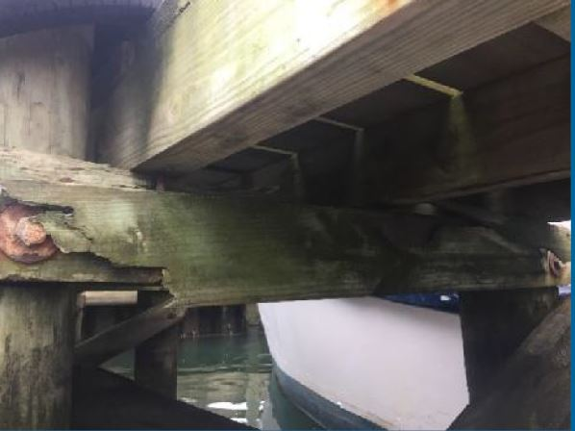
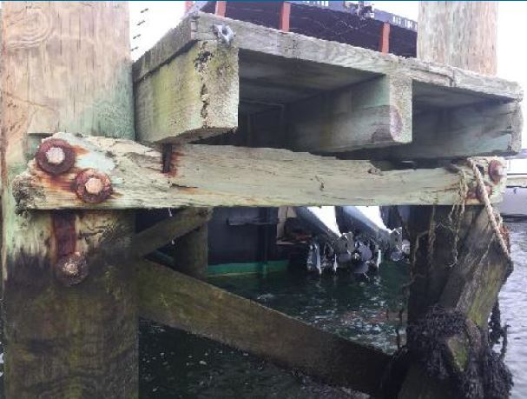
Town of Barnstable - Bismore Park - Timber Piers Repair Memorandum_opt.pdf
Town of Barnstable - Bismore Park - Timber Piers Repair Plan.pdf
FY 2022
OPERATING BUDGET
DECISION PACKAGE
Requesting Dept: MEA |  |  |  |  |  |  |  |  |  | Division: Marina Enterprise
Contact Person: Brian W. Taylor, Harbormaster |  |  |  |  |  |  |  |  |  | Dept. Priority: 4 of 5
- Decision Package Title: Prince Cove Marina Facility Improvements

- Strategic Plan Priority: Public Health and Safety, Infrastructure

- Classification | Non-Discretionary (Change in law, utility incr., etc.) |  |  |  |  |  |  |  |  |  |  | Discretionary  X
- Decision Package Request:

 |  | Maintain current level of service
Enhanced/Expanded level of service
X

Operating Capital
X
 |  |  |  |  |  | New Item
Replacement
X

(Describe item, new or replacement, in Detailed Description paragraph below)

- Detailed Description of Request:

Requesting one-time funding of $25,000 to replace existing bathroom at Prince Cove Marina.

- If request is involves a position - Attach Employment Requisition form and proposed position description
- If operating capital item - Attach Operating Capital Item Request Listing Form

- Rational/Justification for Request:

The Prince Cove Marina building was constructed in the 1965. The Town of Barnstable purchased the property under the Marina Enterprise Program. Due to age of building and original bathrooms they are in need of replacing and improvements. One current bathroom is not operational (no sink or toilet). The current condition of the working bathroom includes peeling floor paint, deteriorating concrete floors, non-insulated walls and one operational toilet and sink. The current bathrooms are not ADA complaint. If this request is for filled the bathroom will become ADA compliant.

- How Efficiency and Effective will this Request be providing this Service? (Explain):

Maintenance will help improve public/user enjoyment of a Town of Barnstable facility.

- Impact on Service if Not Funded (Explain):

Future maintenance cost may increase as facility deteriorates. Public may not have a restroom facility to use at a municipal marina and boat ramp.

- Breakdown of Total Costs By Line Item:

Expense Line Item |  |  | Account Number
Description |  |  | Org Code |  |  |  |  | Object Code |  |  |  |  | Amount
Prince Cove Marina Bathroom Repair |  |  | New |  |  |  |  |  |  |  |  |  | $25,000
 |  |  |  |  |  |  |  |  |  |  |  |  | $
 |  |  |  |  |  |  |  |  |  |  |  |  | $
 |  |  |  |  |  |  |  |  |  |  |  |  | $
 |  |  |  |  |  |  |  |  |  |  |  |  | $
 |  |  |  |  |  |  |  |  |  |  |  |  | $
 |  |  |  |  |  |  |  |  |  |  |  |  | $
 |  |  |  |  |  |  |  |  |  |  |  |  | $
 |  |  |  |  |  |  |  |  |  |  |  |  | $
 |  |  |  |  |  |  |  |  |  |  |  |  | $
 |  |  |  |  |  |  |  |  |  |  |  |  | $
 |  |  |  |  |  |  | Total Expenses |  |  |  |  |  | $25,000
- Revenue Offsets: |  |  |  | Yes  x |  |  |  |  | No
Explanation if Yes Above Explain By Describing Funding Sources: Funding offset will be Marina Operations Program Surplus funds.

Funding Offsets (Fees, Grants, Internal, Budget Line Transfer)
Proposed Funding Source |  |  |  | What is the Price or Lump Sum? |  |  |  |  |  |  | Amount
Marina Operation Program |  |  |  | Surplus |  |  |  |  |  |  | $25,000
 |  |  |  |  |  |  |  |  |  |  | $
 |  |  |  |  |  |  |  |  |  |  | $
 |  |  |  |  |  |  |  |  |  |  | $
 |  |  |  |  |  |  |  |  |  |  | $
 |  |  |  |  |  |  |  |  |  |  | $
 |  |  |  |  |  |  | Total Offset |  |  |  | $25,000
 |  |  |  |  | Net Bal. (Expenses – Revenues) |  |  |  |  |  | $0
- Further Explanation if Needed:

ATTACHMENT: Please provide any support (including photos) for cost for materials or comparable personnel wages.

FY 2022
OPERATING BUDGET
DECISION PACKAGE
Requesting Dept: MEA |  |  |  |  |  |  |  |  |  | Division: Marina Enterprise
Contact Person: Brian W. Taylor, Harbormaster |  |  |  |  |  |  |  |  |  | Dept. Priority: 5 of 5
- Decision Package Title: Seasonal Pay Rate Increase

- Strategic Plan Priority:

- Classification | Non-Discretionary (Change in law, utility incr., etc.)  X |  |  |  |  |  |  |  |  |  |  | Discretionary
- Decision Package Request:

Maintain current level of service
x

 |  | Enhanced/Expanded level of service
 |  | Operating Capital
 |  |  |  |  |  | New Item
 |  |  |  |  |  | Replacement
(Describe item, new or replacement, in Detailed Description paragraph below)

- Detailed Description of Request:

Proposal is to fund the mandated increase in the hourly pay rate of all Seasonal Marina Staff Positions by $.75 cents an hour. Positions include Season Dock Master/Assistant Harbormaster’s, Season Security Officer/Assistant Harbormaster

- If request is involves a position - Attach Employment Requisition form and proposed position description
- If operating capital item - Attach Operating Capital Item Request Listing Form

- Rational/Justification for Request:

This increase is a town wide increase on seasonal positions.

- How Efficiency and Effective will this Request be providing this Service? (Explain):

This will give the town an opportunity to offer a more competitive pay rate and to be able to keep employees that have experience from past years.

- Impact on Service if Not Funded (Explain):

Marina Enterprise Program would not have enough money in line item “Temporary Salary and Wages” for Personnel Cost to fund positions.

- Breakdown of Total Costs By Line Item:

Expense Line Item |  |  | Account Number
Description |  |  | Org Code |  |  |  |  | Object Code |  |  |  |  | Amount
Salary/Wages-Temp |  |  | 668023 |  |  |  |  | 512000 |  |  |  |  | $9,000
 |  |  |  |  |  |  |  |  |  |  |  |  | $
 |  |  |  |  |  |  |  |  |  |  |  |  | $
 |  |  |  |  |  |  |  |  |  |  |  |  | $
 |  |  |  |  |  |  |  |  |  |  |  |  | $
 |  |  |  |  |  |  |  |  |  |  |  |  | $
 |  |  |  |  |  |  |  |  |  |  |  |  | $
 |  |  |  |  |  |  |  |  |  |  |  |  | $
 |  |  |  |  |  |  |  |  |  |  |  |  | $
 |  |  |  |  |  |  |  |  |  |  |  |  | $
 |  |  |  |  |  |  |  |  |  |  |  |  | $
 |  |  |  |  |  |  | Total Expenses |  |  |  |  |  | $9,000
- Revenue Offsets: |  |  |  | Yes  x |  |  |  |  | No
Explanation if Yes Above Explain By Describing Funding Sources: Funding offset will be Marina Operations Program Surplus funds.

Funding Offsets (Fees, Grants, Internal, Budget Line Transfer)
Proposed Funding Source |  |  |  | What is the Price or Lump Sum? |  |  |  |  |  |  | Amount
Marina Operation Program Revenue |  |  |  | $9,000 |  |  |  |  |  |  | $9,000
 |  |  |  |  |  |  |  |  |  |  | $
 |  |  |  |  |  |  |  |  |  |  | $
 |  |  |  |  |  |  |  |  |  |  | $
 |  |  |  |  |  |  |  |  |  |  | $
 |  |  |  |  |  |  |  |  |  |  | $
 |  |  |  |  |  |  | Total Offset |  |  |  | $9,000
 |  |  |  |  | Net Bal. (Expenses – Revenues) |  |  |  |  |  | $0
- Further Explanation if Needed:

ATTACHMENT: Please provide any support (including photos) for cost for materials or comparable personnel wages.
Harbormaster
Boat/Ramp Attendant |  | 66052 | T690 | $ 15.50 | 39
Seasonal Dockmaster/Asst. Harbormaster |  | 66050 | T764 | $ 17.50 | 47
Seasonal Security Officer/Asst. Harbormaster |  | 66051 | T688 | $ 17.50 | 47
Seasonal Pumpout Operator/Asst. Harbormaster |  | 66053 | T698 | $ 19.25 | 54
Seasonal Mooring Officer, Harbormaster |  | 66054 | T765 | $ 19.25 | 54
Seasonal Security Officer, Harbormaster (new 07) |  | 66055 | T766 | $ 18.50 | 51
Seasonal Waterways Assistant, Harbormaster |  | 66058 | T767 | $ 19.25 | 54
Seasonal Waterways Enforcement Officer |  | 66060 | T719 | $ 19.25 | 54
Seasonal Marina Facilities Maintenance Laborer |  | 66059 | T711 | $ 20.00 | 57
Seasonal Harbor/Ramp Attendant |  | 66057 | T707 | $ 15.50 | 39

